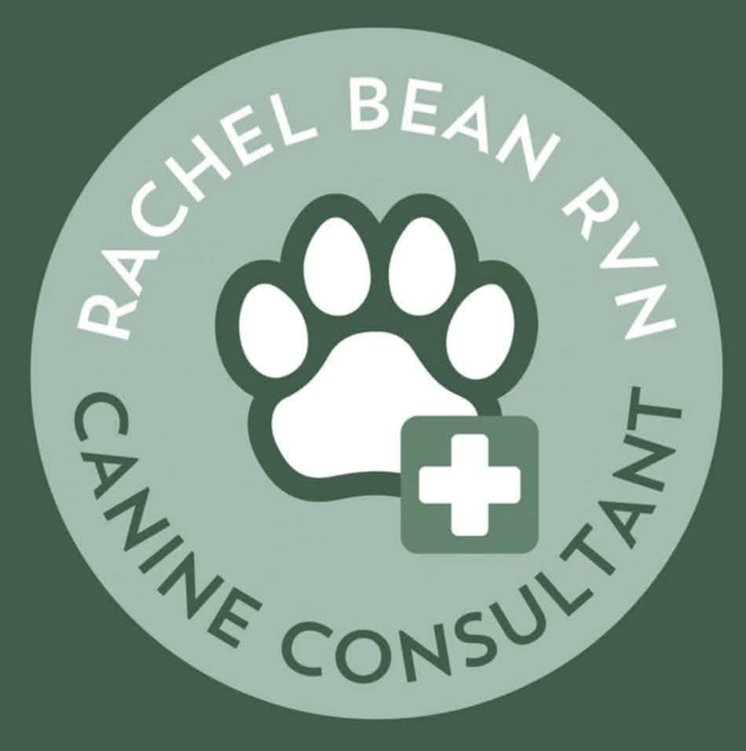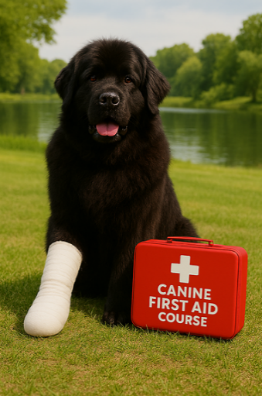

EMERGENCY CANINE FIRST AID COURSE
Sunday May 24th
Standard Water tests Sat/Mon
09.00am – 12.30pm
£35.00pp
Manvers Lake Conference Room,
Station Road,
Wath-upon-Dearne
Rotherham.
S63 7BU

Presented By
RACHEL BEAN
RVN BVNA MCFBA (AnBeh)
Award winning Training provider with the iPET Network group and internationally recognised canine first aid trainer.

The programme will cover life threatening emergencies, blood loss, choking, hyperthermia, bloat and CPR.

All attendees will receive a certificate.

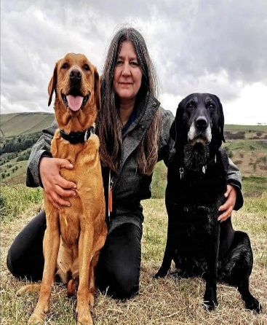

Places are limited, so book early to reserve your ticket. Full payment is required in advance.
Payment Options:
- Online Banking: K J and S L Sanders Sort Code 20-10-71, Account Number: 10230553 Payment Ref: your name. Please attach proof of transaction and email confirmation of your payment to slsanders@btinternet.com

- Cheques: Please make all cheques payable to S L Sanders and post to 1, Hill Side, Heaton. Bolton BL1 5DT. Please include your postal or email address.

