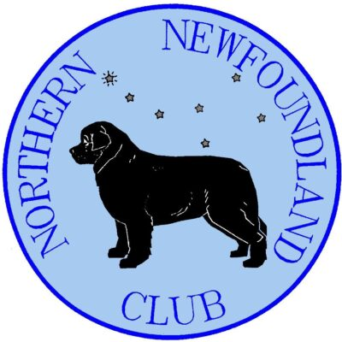
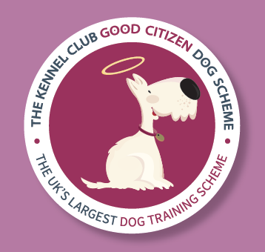
Manor Farm Easter Weekend

Good Citizen Dog Scheme – Bronze Test

Friday 3rd April 2026

The NNC will be hosting a Good Citizen Dog Scheme Bronze Exam at the Manor Farm weekend

The requirements of the GCDS Bronze test can be found here: gcdsbronze.pdf

The test will be examined by qualified judge Sandra Constable

If you are interested in entering the GCDS exam at Manor Farm, please provide your details below:

Dog Name………………………………………………………..

Handler Name………………………………………………………………..

Contact Number……………….…………………………

Email Address……………………………………………………………….…………………………………………………………

There is no entry fee for the GCDS Bronze exam – however we will collect donations to NNC Welfare from entrants wishing to do so

Please post this form back to the Event Manager:
Helen Cadman, 1 Leighs Cottages, Wellfield Lane, Timperley, Cheshire, WA15 7AE.
Mobile: 07810 528260; Email: hvcadman@gmail.com

Closing date Saturday 28th March 2026

