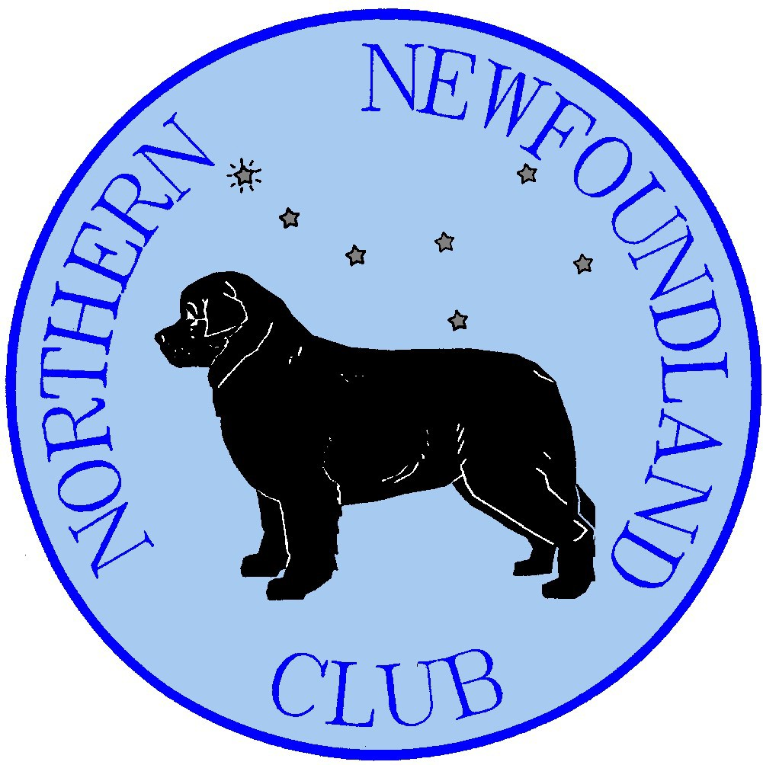

THE NORTHERN NEWFOUNDLAND CLUB
WSC Committee Application Form

Candidates please note, copies of this form will be sent to all club members (WSC & Main Committee).

Please complete the form in BLOCK CAPITALS or on a computer.

Candidate Details

Name Affiliated training Group

Address

To be completed by the Candidate: |  | Answer
How long have you been a member of the Northern Newfoundland Club?
Breed knowledge | How long have you been involved with the Newfoundland breed?
Breed knowledge | Number of years owning Newfoundlands?
Breed knowledge | Number of Newfoundland dogs owned in this time.
Practical Working Experience | How many years’ working experience do you have?
Practical Working Experience | How long have you trained with the group you wish to represent?
Practical Working Experience | Have you trained with any other groups? If so, which one and for how long?
Practical Working Experience | Number of Newfoundlands worked in that period (your own).
Practical Working Experience | What is the highest water level you have entered?
Practical Working Experience | What is the highest draught level you have entered
Working Support | What is the highest water level you have stewarded (in a test)?
Working Support | What is the highest draught level you have stewarded (in a test)?
Test Managing Experience | Have you ever been Test Manager for a water test?
Test Managing Experience | Have you ever been Test Manager for a draught test?
Judging Experience | Have you ever judged at a water test?
Judging Experience | What is the highest water level you have judged?
Judging Experience | Have you ever judged at a draught test?
Judging Experience | What is the highest draught level you have judged?

What canine club or society experience do you have?

Which Working events have you attended this year?

Please use this box to explain why you wish to serve as your group’s representative on the WSC.

Proposer |  | Seconder
Name: |  | Name:
Address: |  | Address:
Signed: |  | Signed:
Date: |  | Date:

General:

I have/have not* bred Newfoundlands. My first litter was in I have bred litter(s).

I do/do not* expect to breed in the future.

*Delete as appropriate.

I confirm that since becoming a member of the Club in I have complied with, and will continue to comply with, its Rules, Code of Ethics and Good Breeding Guidelines. (Please comment overleaf, if necessary).

Declaration:
I confirm that I am not in breach of Club Rule Number 8.6.
I am aware of the need for Committee confidentiality.
I understand that should I be found to be in breach of committee confidentiality I will be expected to resign immediately.

Signed Date

