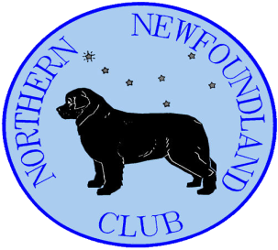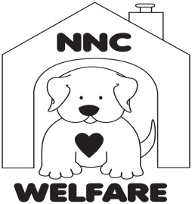
NORTHERN NEWFOUNDLAND CLUB
Walk for Welfare
Walk Venue: ___________________
Walk Date: __________________
Sponsorship form
Name (Address – optional) | Amount | Paid (Y/N)
Total:

Please arrange to have all monies available to hand over to your walk host, or pay this as soon as possible.
Thank You for your support.

